THE SHAKER SCREEN

General Description
The shaker screen is a manually operated, portable device used by archaeologists to separate the remains of past cultures from the soil in which they are embedded. Essentially a filter, the shaker screen traps objects larger than 1/8 inch while allowing anything smaller to pass through. This process requires movement or shaking of the screen; from this the implement derives its name. It is a simple, yet efficient device sturdily constructed of wood and metal. In use, the shaker screen resembles a small two-legged table, but when folded is similar in size and weight to a large, moderately full suitcase. The device consists of three functional elements: the screen box, the legs, and the handles.

The Screen Box
The screen box is a shallow, rectangular framework of lightweight wood, open at the top to accept soil. The metal screening enclosing the bottom of the drawer-like box sifts the remains from the soil. This network of screening is so tight, an aspirin cannot pass through it (see figure 1). The box performs the essential function in the process of separation; the legs and handles only facilitate the action.
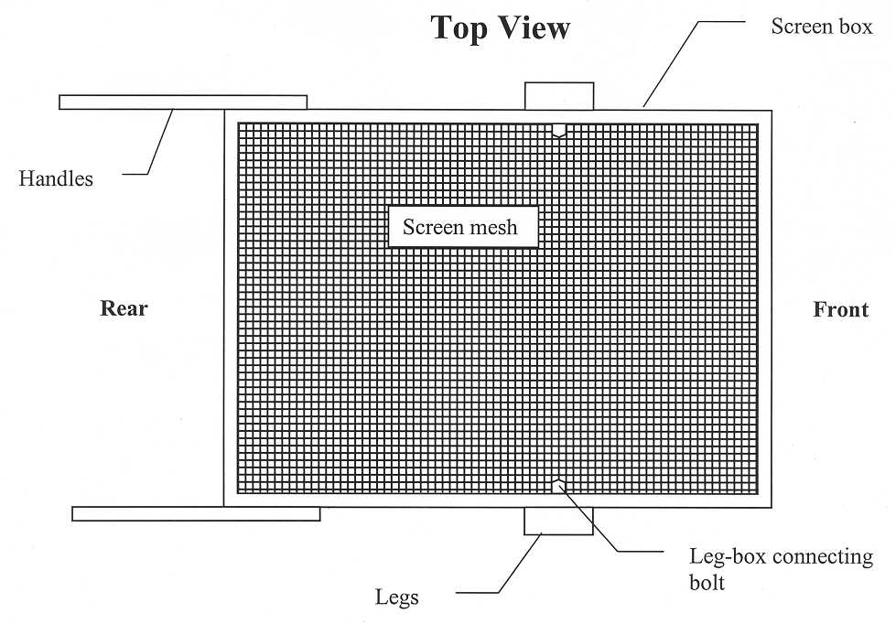
Figure 1. The metal screening enclosing the bottom of the drawer-like box sifts the remains from the soil.

Longer than it is wide (32 inches x 24 inches), the screen box holds approximately one cubic foot of soil per load, an amount equivalent to two bucketfuls. The 4-inch high walls of the box retain soil and artifacts, preventing spillage during operation. Firmly affixed to these walls is a section of 1/3-inch mesh galvanized steel screen, a common fencing material, which encloses the entire base of the box. The sharp edges of the screen protruding on the outside of the box are covered with lath to prevent injury to the user. Metal L-shaped brackets, located on the inside of each corner, provide lateral stability for the box.

The Legs
During use, a pair of wooden legs support the screen box. They also allow the screen box to move back and fourth, rocking on the fulcrum created by the juncture of the legs and box. In a broad sense, the legs function similarly to the fulcrum of a teeter-totter. But unlike the teeter-totter, the legs move along with the screen box forming a continually shifting fulcrum. This relationship causes the rocking motion necessary to agitate the soil within the screen box.

To ensure stability, the legs are made from more substantial wood than is the box. These 30-inch-long 2 x 4s elevate the screen box to a comfortable height for the user. The legs are arranged in parallel and joined by two 1 x 4 cross-members, resembling a segment of a ladder (see figure 2). The distance from leg to leg is slightly wider than the shorter outside dimension of the screen box (24 inches). A 3 ½-inch bolt extends through a hole in the upper end of each leg and through a matching hole in the long walls of the screen box, attaching the legs to the box. These bolts are not tightened completely, permitting the box to hinge freely within the framework of the legs. The legs connect to the box slightly forward of its center, a position which helps to create a rocking motion. Because of the relationship of the legs to the box, the two fold together into a compact unit for storage or transport.

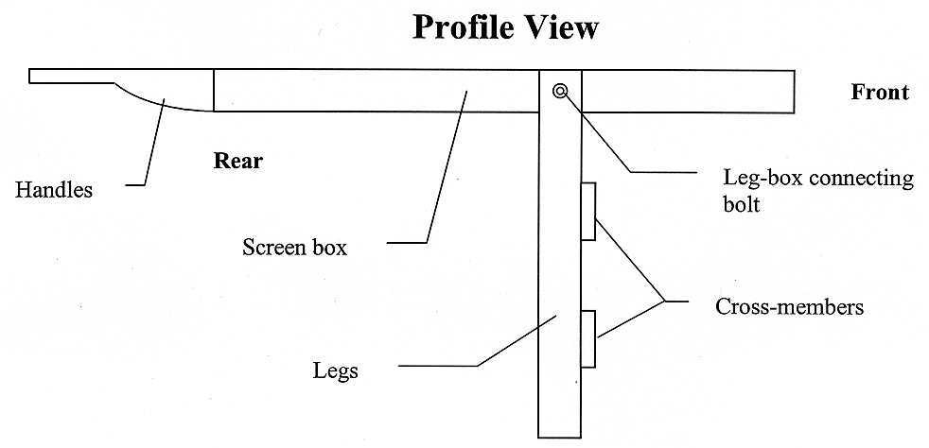
Figure 2. The 30-inch-long legs elevate the screen box to a comfortable height for the user. The legs are arranged in parallel and joined by two 1 x 4 cross members.

The Handles
Securely attached to each long wall of the screen box is a wooden handle. The handles protrude from the rear of the box; this is the end farthest away from the leg attachments. Gripped like a tennis racquet, the handles are the means by which the archaeologist grasps the screen box. The handles align parallel to the long walls of the box. Tapering as they extend out from the screen box, the handles curve gently, conforming to the shape of the hand. Constructed from durable, but lightweight wood, the handles are sanded and lacquered to prevent injury. The handles are 8 inches long, 1 inch thick, and vary from 4 inches wide at their attachment to the box to 2 inches on the grip.

Operation
After pouring a load or soil into the screen box, the screener (operator) grasps the handles to adjust the level of the box. When the legs extend perpendicularly down from the box and set firmly on the ground, the shaker screen is balanced. By alternately pushing and pulling the screen box on its long axis, the fulcrum formed by the juncture of the legs and the box creates a rocking motion. This motion agitates the soil, forcing all particles smaller than 1/8 inch to fall through the screen. The walls of the box prevent the load from spilling during this vigorous movement. Shaking continues until none of the smaller particles remain in the screen. From the items left in the screen, the archaeologist sorts out and collects the cultural remains which include bones, stone implements, and fragments of pottery (see figure 3). The screen box is then emptied of all non-cultural material (e.g., rocks, twigs, insects), thus preparing it to receive another load.
Sorting Cultural Remains
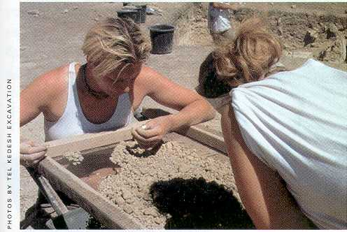

Figure 3. Student archaeologists sort out and collect cultural remains which include bones, stone implements, and fragments of pottery (Biblical Archaeology Review 2000, p. 15).

Reference
Woollae bullae: Team hopes to find more seals at kadesh. (2000) Biblical Archaeology Review. 26.3, 15.

